|  |  |
| --- | --- |
| Lernfeld 2 – Einfache Baugruppen und Systeme prüfen | Klasse: BSRMP17_ (Kfz-U) |
| Übung: Messen mit dem Messschieber | Name: |
| BBS Winsen (Luhe) – Giesler | Datum: |

Messe alle Längen A ... H und notiere Deine Messwerte in der Tabelle in mm.

|  |  |  |  |  |  |  |  |  |
| --- | --- | --- | --- | --- | --- | --- | --- | --- |
| Nr. | A | B | C | D | E | F | G | H |
| 1 |  |  |  |  |  |  |  |  |
| 2 |  |  |  |  |  |  |  |  |
| 3 |  |  |  |  |  |  |  |  |
| 4 |  |  |  |  |  |  |  |  |
| 5 |  |  |  |  |  |  |  |  |
| 6 |  |  |  |  |  |  |  |  |
| 7 |  |  |  |  |  |  |  |  |
| 8 |  |  |  |  |  |  |  |  |
| 9 |  |  |  |  |  |  |  |  |
| 10 |  |  |  |  |  |  |  |  |
| 11 |  |  |  |  |  |  |  |  |
| 12 |  |  |  |  |  |  |  |  |
| 13 |  |  |  |  |  |  |  |  |
| 14 |  |  |  |  |  |  |  |  |
| 15 |  |  |  |  |  |  |  |  |
| 16 |  |  |  |  |  |  |  |  |
| 17 |  |  |  |  |  |  |  |  |
| 18 |  |  |  |  |  |  |  |  |
| 19 |  |  |  |  |  |  |  |  |
| 20 |  |  |  |  |  |  |  |  |

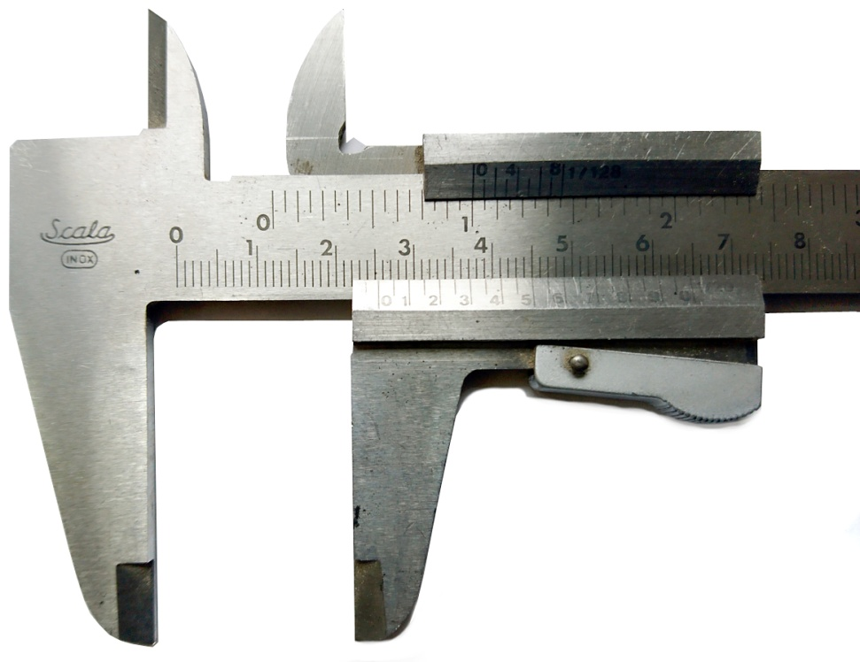

Nr. 5

25,5 mm

A

B

C

D

E

G

H

F